Ascent I
Upgrade your encoding with the Aim step. The first part of our 3-step hyper-efficient encoding system.
Overview and recommendations
Key dimensions | Deep processing, self-regulation
Recommended pace | Most learners see best results with 8 to 10 hours of theory across 4 to 6 weeks.
Recommended practice | Most learners see best results with 4 to 6 weeks of practice.
Progression tips | The techniques in this stage require more practice compared to theory than previous stages. Avoid accumulating more than 2 focus tasks at a time before moving on. It may be overwhelming to progress through too many lessons too quickly, as each lesson is designed to give you more conditions and nuances to think about after you have already practised. Diligent and frequent Kolb's will be crucial for smooth progression.
How this stage helps you
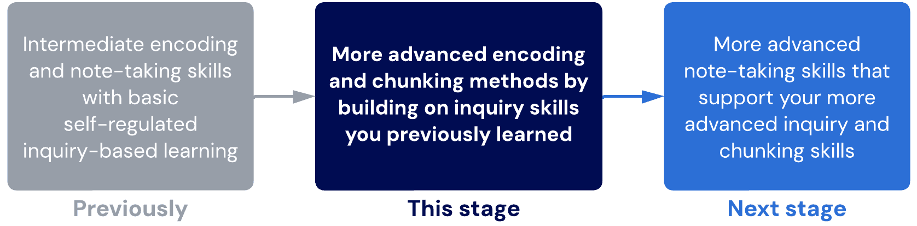

Lessons
- Bear Hunter System: Aim
An overview of Aim, the first step of our Bear Hunter System of learning.
- How to aim
Learn to optimise the quality of your questions and, therefore, the relationships you discover.
- Aim – question quality
Learn which questions are more likely to give you high-quality connections than others.
- Inquiry clean-up
In this lesson, we start to reduce the volume of questions and increase the quality of each one.
- Barriers to aiming
We explore some common reasons people may struggle with using the Bear Hunter System.
Sublessons: Common chunking mistakes
- Aim examples

This lesson covers a variety of demonstrations of the Aim step on different subjects.
Sublessons:
- Demonstration of core techniques 2
- Biology 1
- Biology 2
- Chemistry
- English and languages – introduction
- Languages – aim
- English – unfamiliar text
- English – text response
- Math
- Deep dive: anatomy
- Chunking for medicine
- Distractions
In this lesson, you'll learn how cognitive switching penalty can influence your focus and distractibility.
- Maintaining focus
We extend and reinforce what you've already learned about creating focus to upgrade your self-management toolkit.
- Ascent I check
This final check will help you identify if you're ready to move onto the next stage.

- Bear hunter system – aim
Moving into Ascent 1
By now, you should have:
- Realised that your quality of learning is affected by the type of thinking (cognitive processes) you engage in.
- Experienced higher-order learning, which involves comparing, contrasting and prioritising information instead of just learning it in isolation.
- Practised using non-linear notes to represent the maps and schemas formed through higher-order learning.
- Experienced how your method of writing notes can help or hinder your ability to engage in higher-order thinking.
- Used questioning and inquiry-based learning (via the TLS) to guide your thinking and the types of relationships you explore.
- Experienced how asking different questions makes you explore different types of relationships, which changes the types of schemas and maps you form.
- Practised forming backbones to your learning, which forces you to prioritise, re-arrange, and re-label groups of information based on what makes the most sense to you.
- Experienced how forming backbones can help you see information in a different order and perspective from how it’s taught or presented in textbooks.
- Practised spaced interleaved retrieval for different orders of learning.
- Utilised Kolb’s experiential cycle to drive improvements.
- Experienced how the quality of your reflection and abstraction dramatically affects the usefulness of your experiments.
- Started to intuitively see progress through the lens of marginal gains instead of as binary “success or failure” or “big leaps”.
- Practised using various self-management techniques (time and task management) to maintain optimal and healthy productivity levels.
Alert
If you haven’t completed all these, we recommend practising your current skillset more before moving on. Taking time to reach moderate to high conscious competency in the previous techniques prevents technique errors and cognitive overload.
About this stage
The following are new techniques or systems you will learn in Ascent I.
New Techniques | Rationale
Aim | An intermediate-level skill for inquiry-based learning. It builds on the skill you developed from the Traffic Light System (red light).
Maintaining focus | An extension of the focus techniques from previous stages.
The following are techniques from previous stages that you should continue using.
Technique | Notes
Traffic light system (green light) | While the red light will be replaced by “Aim”, the green light will not be replaced until later in Ascent II.
Scheduling basics | Continue to refine and habituate your scheduling so it is more personalised for you. Be critical about what is working well and what isn’t.
BEDS-M | Lock in the habits of BEDS-M during this stage. We will build on this at Basecamp.
SIR | There is no change to the technique, but you will start noticing that you will need to revise less as your retention increases.
Non-linear note-taking | All notes should always be processed. In Ascent II, we will replace this, but for now, continue to make your chunks clearer and your relationships more obvious.
The following techniques will be replaced and upgraded.
Prior Technique | Replaced with…
Traffic light – red light | Bear Hunter System – Aim
Prestudy basics | Bear Hunter System – Aim

- How to aim
Overview
Aiming is about pointing your brain in the right direction. By asking the right questions, we encourage our brain to think in specific patterns and form specific relationships.
Two questions that consistently create high-quality networks for any subject are:
- Why is this important?
- How is this related to ___?
Purpose of this step
- To make new information relevant and immediately form networks
- To activate higher-order learning as early as possible
- To create groups (chunks) and relationships that are robust, versatile and suit our retrieval needs
Meta-checklist
The table below outlines how using this technique can feel and what these feelings mean at a cognitive level. Refer to this table to improve your metacognition and ensure you understand the purpose of the technique. Connecting your emotional experience with the cognitive processes of learning helps you make fine-tuned adjustments and solve any technique issues more easily.
How it can feel | Cognitive outcomes
Same as for the Traffic-Light System (see the meta-checklist here). | Same as for the Traffic-Light System (see the meta-checklist here).
Overwhelming, due to the number of relationships you discover while answering the question, “Why is it important?”. | Rapidly creates a network of possible relationships for you to refine.
Confusing, as there are many possible non-linear structures for the main concepts, and it takes significant effort to decide which structure makes the most sense. | Adds a high degree of prioritisation and evaluation (one of the highest orders of learning).
Time-consuming, because each keyword or concept requires such deep examination. | Deep examination consolidates your learning. This feeling will fade as your speed and efficiency gradually increase. Over time, your brain becomes better at creating networks, prioritising them, and deciding on the best hypothetical structure.
Common questions
How does Aim fit with prestudying?
Prestudy and Aim often overlap. However, they are not the same thing.
The purpose of prestudying is to prime our brain to create relationships before an intensive main learning event. We explore the purpose of prestudying in this article here.
The Bear Hunter System is a system of learning, whereas prestudy is a chronological step in the learning journey. The Aim step should be one of (if not the very first) step in the learning journey.
If this happens before an intensive main learning event, this can be considered prestudy. If there is no prestudy, Aim should still be the first step of the learning journey. As it is very difficult to manage this kind of thinking in an intensive lecture or class, Aim may have to occur after the main learning event during a self-study session instead. This is not optimal.
However, the amount you can cover in prestudy is a decision. You could do a very brief prestudy of just 5 or 10 minutes, in which time a full Aim may not be possible. In this case, you would do a very superficial Aim to develop only the largest chunks and major relationships.
Alternatively, it's possible to do a much more comprehensive prestudy. In this case, we could do a full Aim and even add more detail. Once you learn the Shoot step which comes after Aim, this could also be done during prestudy.
In summary, prestudy is about when you start learning. The Bear Hunter System is how you learn.
Once I learn Aim, should I stop doing the TLS red light?
Yes, the Aim completely replaces TLS red light. While red light creates some initial connections and relationships, Aim is a more focused and strategic use of questions to create only those relationships that are likely high-yield.
What is the difference between "Why is it important" and "How does it relate to ____"?
These two questions may seem conceptually identical. However, we have arrived at these two key questions after years of trial and observation.
Why is it important?
This question focuses our attention on the big picture. It creates a focus, purpose, and alignment between the ideas. It helps us push through to the Evaluate level of thinking where we make judgments and prioritisations of networks. Asking this question critically helps our chunks become more memorable and intuitive.
How is it related to [another concept]?
This question explores additional relationships that may not be obvious. When we explore why something is important, it is difficult to escape our existing biases and preconceptions about the information. Two concepts may initially seem unrelated, and only when forced to explore their relationship do we find new perspectives and potential chunks. Sometimes, this leads us to re-evaluate our entire chunk structure and reasons for importance.

- Aim – question quality
Types of questions
‘What’ questions are usually too simple and unconnected to produce high retention. ‘Why’ and ‘How’ questions connect the information to other pieces of information and therefore are much more meaningful.
Questions that are more emotional or personal and that spark curiosity also connect much more. Since the objective is to enter a problem-solving mindset, do not ask questions about problems to which you already know the answer. If you are genuinely curious about the topic, you will be able to generate more knowledge.
Note
Asking the right questions may be challenging in the beginning. However, by generating more curiosity, you will also find that you start to enjoy studying more, making it much easier to learn and retain information.
Table of contents
Quiz: Question quality critique
In this quiz, we'll critique the quality of various different questions to help you develop a discerning eye for high-yield vs. low-yield questions.

Question 1
Which of the following question types is the best at creating relationships and structure in learning?
What is metacognition?
What are the different types of metacognition?
Why is metacognition important?
Who initially coined the term metacognition?

Ans: Why is metacognition important?
Learning notes
The question “why is _______ important?” is one of the most high-yield questions you can ask. It forces us to not only examine a fact or concept in relation to other facts and concepts, but we must also make a judgment on how important that relationship is.
This facilitates higher-order learning and thinking which improves retention and depth of understanding.

Question 2
Which of the following situations would significantly reduce the usefulness of asking “why is _______ important?”. Select the most correct answer.
Asking this question early in the learning process when we don't even know what something means or understand it.
Answering the question with a single linear answer.
There are no situations where asking this question can be significantly less effective.
Asking this question too often, causing repetition of the same relationships and ideas.

Ans: Answering the question with a single linear answer.
Learning notes
When this question is answered by finding only a single relationship, the usefulness of the question diminishes significantly.
This is because the purpose of asking this question is to find multiple relationships and force ourselves to judge the importance of each relationship. The need to rationalise and justify our decision is what forces higher-order learning and the development of a robust knowledge network.
When learners answer a question with a single, simple answer, we call this problem “simple question and answer”. It is a common way that some learners avoid the discomfort of deeper processing by subtly modifying their inquiry-based learning technique.

Question 3
Your friend creates a series of Aim questions and wants your feedback. On the topic of metacognition, they have written:
What is a metacognitive artifact?
What are examples of metacognitive artifacts?
What is social metacognition?
What are examples of social metacognition?
You advise them to make more questions around why each concept is important. However, they reply that their final question which asks about examples of social metacognition already provide the reasons why it is important.

Question 3.1
Which of the following statements is true?
Gaining examples of importance is indeed sufficient. A separate question is not necessary if one of the questions asks to find examples of a concept.
Asking about examples is usually not sufficient, but because the other questions cover the definitions, it is sufficient in this case.
Asking about examples is usually not sufficient, including in this case.
Asking about examples is usually sufficient, but not in this case.

Ans: Asking about examples is usually not sufficient, including in this case
Learning notes
Asking about examples is usually not a sufficient replacement for asking more broadly about why something is important. Examples can be lower-order, which does not necessarily improve the relationships we form between other concepts.
Examples also may not help us to chunk information in the best way because it does not sufficiently help us find various similarities between concepts that could be used for grouping.

Question 3.2
Which of the following questions could also be used to build relationships other than “why is _________ important?”. Select all that apply.
How do metacognitive artifacts occur?
Does social metacognition affect metacognitive artifacts?
What is the purpose of learning and knowing about social metacognition?
How are metacognitive artifacts different from social metacognition?

Ans: Does social metacognition affect metacognitive artifacts?
What is the purpose of learning and knowing about social metacognition?
How are metacognitive artifacts different from social metacognition?
Learning notes
Asking questions that directly probe on relationships, interactions, dependencies and influences of one concept on another concept are effective ways of building relationships. This is weaker than a “why” question because the relationship that is built is only between two (or maybe three) concepts, whereas “why is it important?” questions tend to make us think about multiple concepts simultaneously, as a big picture.
“What is the purpose” questions are similar to “why is it important” questions that have been reworded.
Asking questions like “how does xyz occur?” is a question that asks about how a process occurs. This is the same as “what is the process?” which does not make us think about the information in context with other concepts. This can easily just lead to us memorising the process.

- Inquiry clean-up
In this lesson we will...
- Stop asking "what" questions
- Develop deeper and more refined chunk structures
- Learn to actively manage cognitive load
Quality, not quantity
In the previous stages, we focused on asking a wide range of questions to learn how to invoke curiosity and see how the questions we ask influence the way we process information.
In Ascent I, we will start reducing the number of questions and focusing our efforts on just a few high-yield questions that produce consistent and predictable patterns of connections. By asking questions centred around evaluating and judging the importance of information, our chunks also reflect these judgments.
Therefore, we call this method importance-based chunking, which you will see and hear in our community and Live Clinics often.
Alert
Importance-based chunking is considered a core pillar of our program. It is a method of thinking that will influence every form of information processing from here onwards.
Instructions for importance-based chunking
- Ask the question, "Why is this keyword or concept important?"
- Look for the possible answers (there will usually be multiple reasons for something to be important).
- Move on to the next keyword (in whatever order feels relevant to you) and repeat this process.
- With each keyword, you will start seeing similarities in why some things are important. These become potential chunks.
- Make a judgment on which relationships are important enough to keep and which similarities are important enough to choose to form chunks.
- Continue to build your knowledge by constantly repeating this process for each keyword until you have covered all of the concepts.
While you are performing this, aim to process and consolidate each new keyword as you go. You want to use chunking and mapping to reduce cognitive load before introducing new ideas.
Visualising the process
Keyword list
We start with a keyword list like below. We should be familiar with this by now.
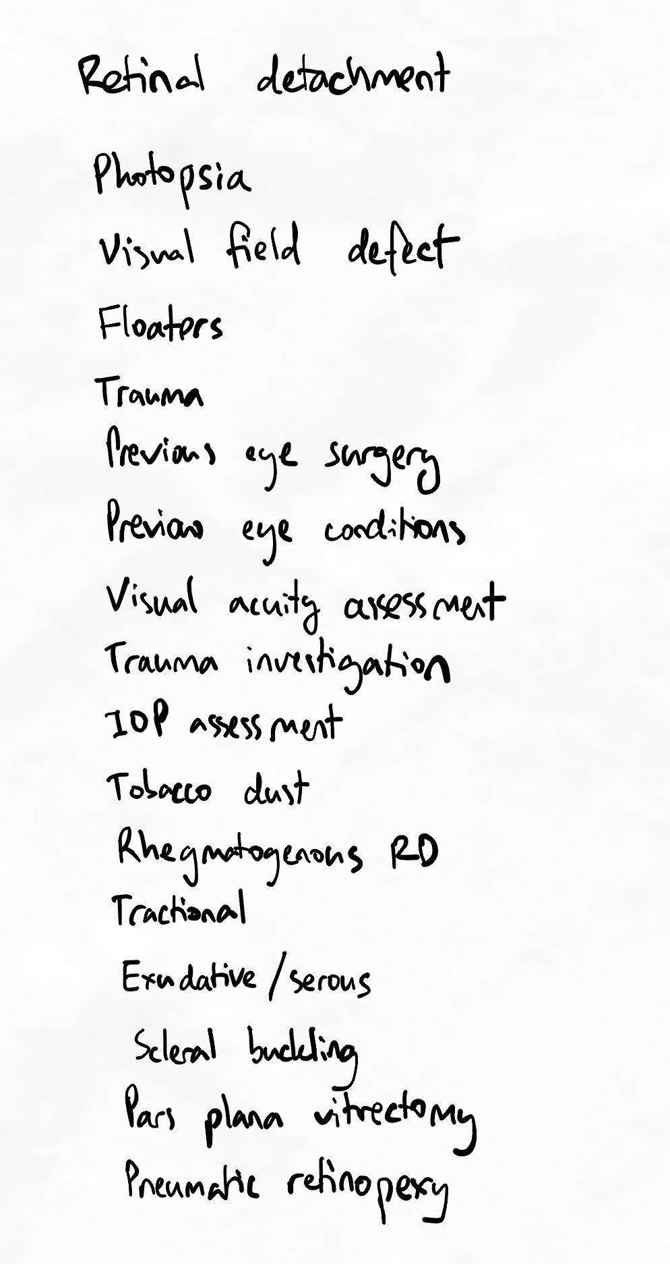Note that the list of keywords does not have any headings or groupings yet. This is to avoid bias and to make sure we form our own independent groups by exercising order control.

Finding first relationships and possible chunks
Next, we start with a keyword we intuitively feel might be relevant or important to start with. We ask why this is important and how it might be related to the other keywords. We repeat this process for a few keywords to get a general sense of how the keywords are related to each other in order to form groups.
In the image below, each yellow link indicates a potential relationship.
For teaching purposes, we have also written the rationale to emphasise that we should try and be clear and explicit about the nature of the relationship instead of simply drawing a line.
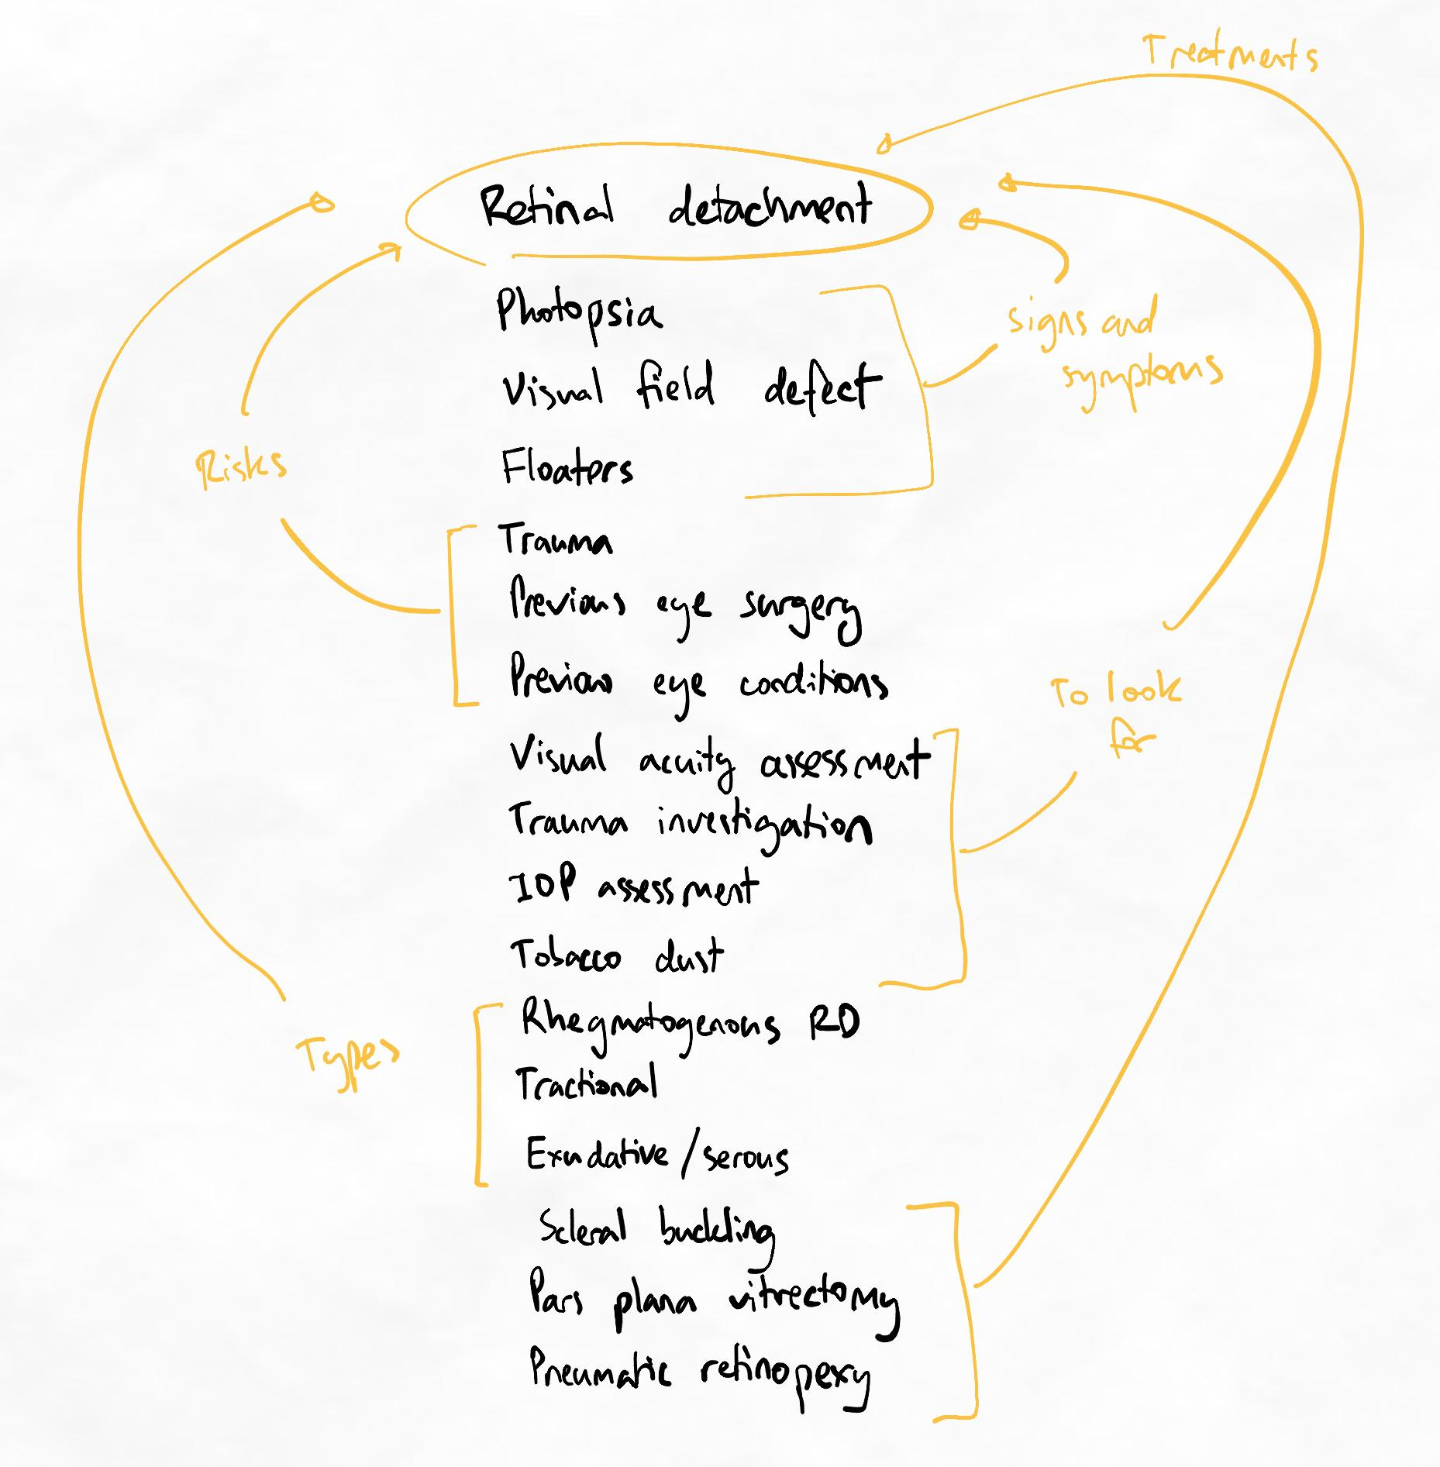At the moment, the relationships are almost exactly the same as how they would be presented in a textbook. However, we will see that later this does not necessarily mean it is optimum.
Representing our new flow non-linearly
Based on this pattern, we can try to hypothesise a chunk structure that is represented as below. Note that this step is simply rearranging the keywords to make it flow more clearly.
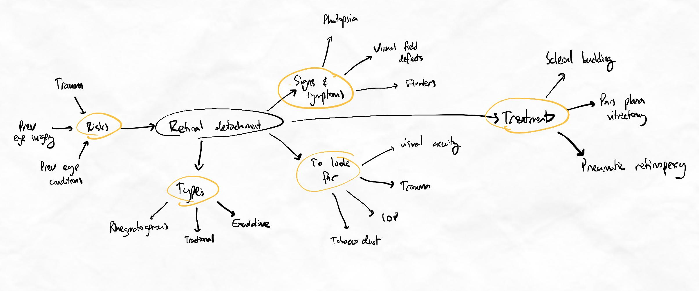This is still a potential structure. Avoid committing to this structure yet. Drawing the map is just to help you visualise the flow and reduce your cognitive load to more manageable levels.
Now that we have mapped the flow, it's easier to now think of additional relationships to see if it makes sense. Trying to think of additional relationships in the list form or simply mentally can create cognitive overload. In some cases, it's possible to map many relationships purely in list form.
Transitioning from list to map depends on how comfortable you are with managing the cognitive load. If in doubt, draft your hypothetical flow earlier rather than later.

Evaluating further relationships
At this point, we can start thinking about how all of these concepts are related to each other. This process of inquiry-based learning is almost identical to the TLS. We ask how it's related to each other, why it's important, and look for information to answer these questions.
As we progress through a few more keywords, we naturally start learning slightly deeper and in more detail than before. We may need to do some online searches or consult other resources to get the answer we want.
Below we've represented the new relationships we found from doing this in yellow. During this process, some additional keywords were revealed that weren't part of our original list. These have been included in pink as they felt important and relevant to include at the big-picture level.
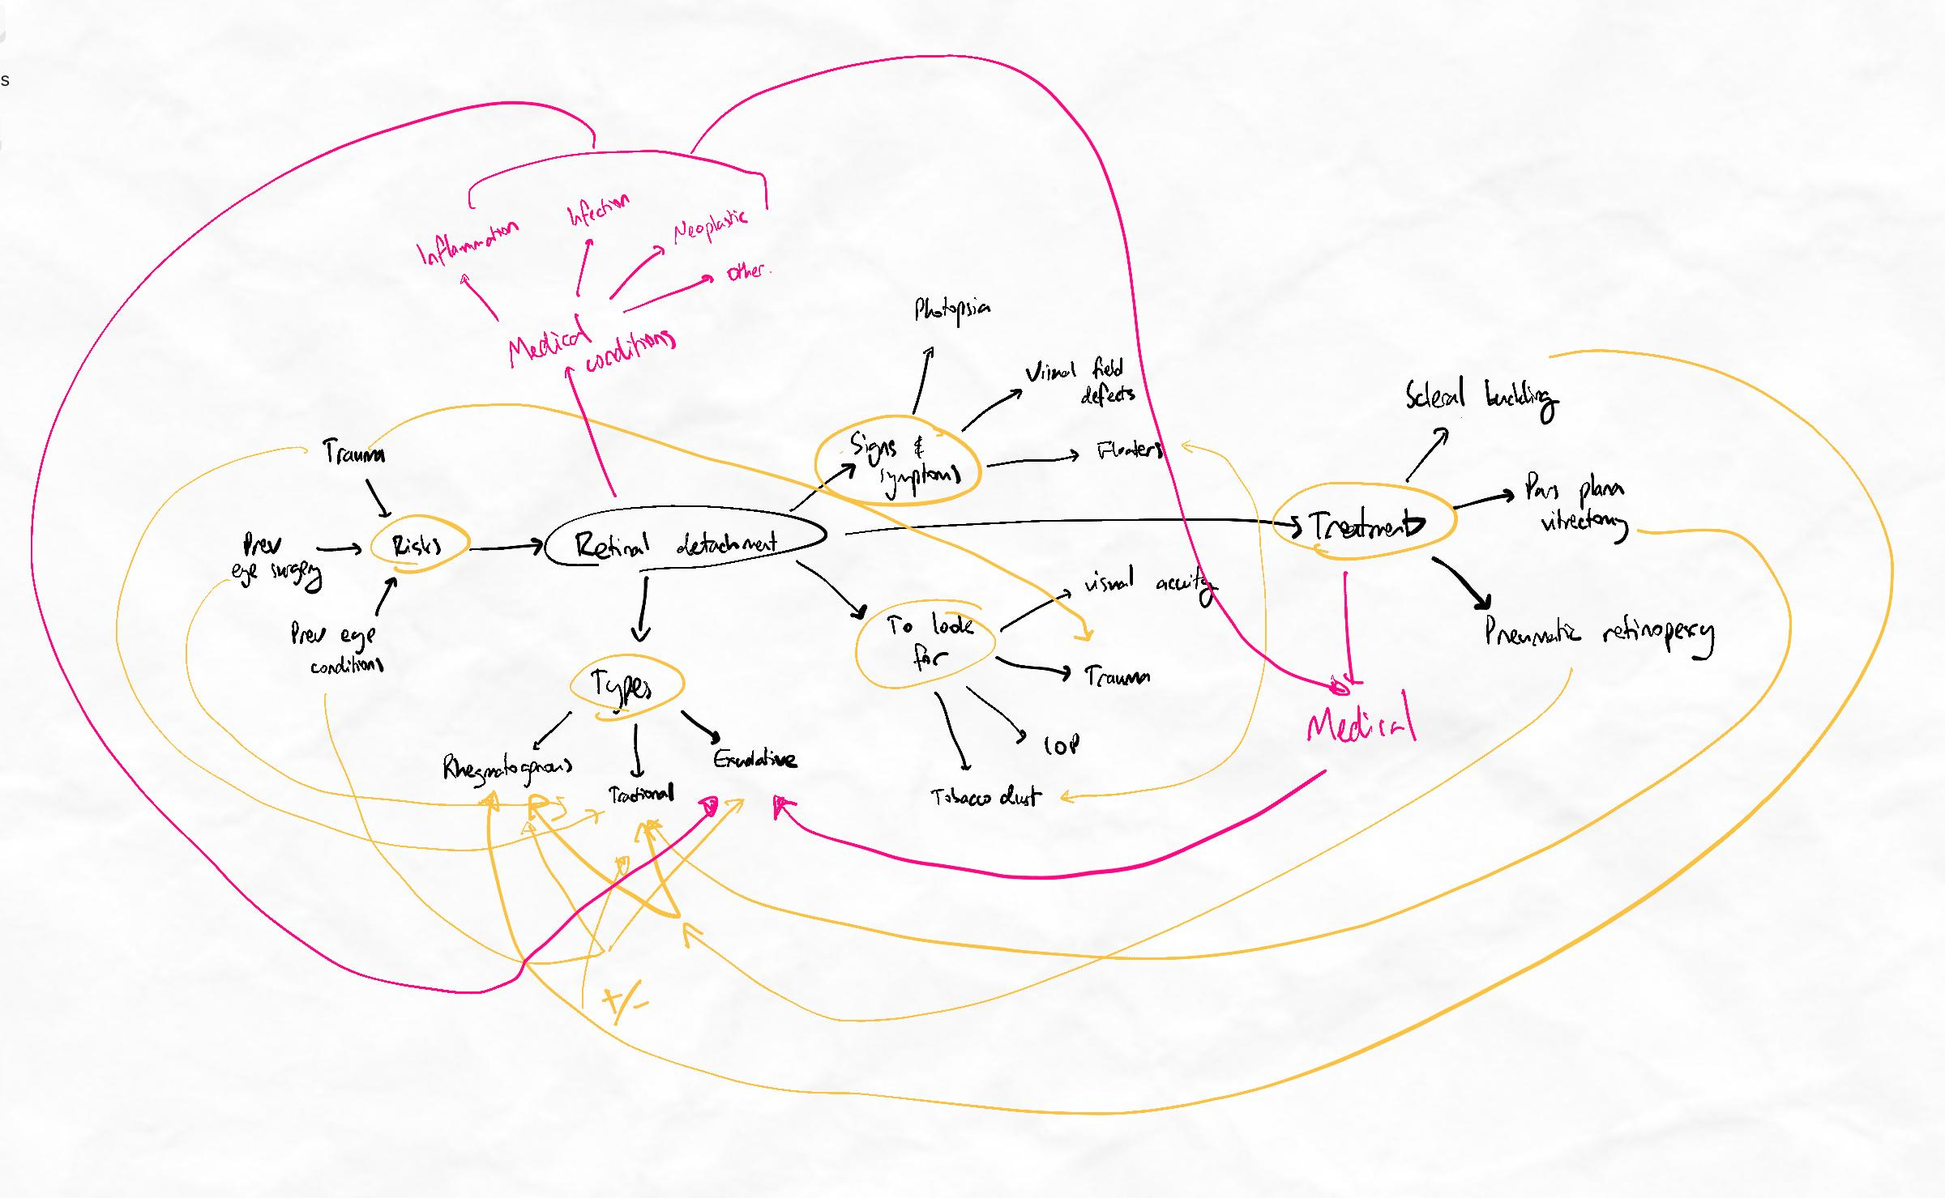This mindmap shows a pattern we call "spiderwebbing". if left at this stage with so many chaotic and messy relationships, we will be easily overwhelmed.
After doing this, we can see that there are many additional relationships between items that are difficult to arrange on our map. When this happens, we can look at the relationships we've found to hypothesise an alternative overall chunk structure.

Revising our chunk structure
We can see that there are many connections around the "Types" chunk in the bottom left. There are also many chunks branching from the central "retinal detachment". By observing this, we can hypothesise a way to chunk the information based on using the "Types" chunk as a more central part of the flow.
After lots more thinking, we might arrive at a flow that looks like the below.
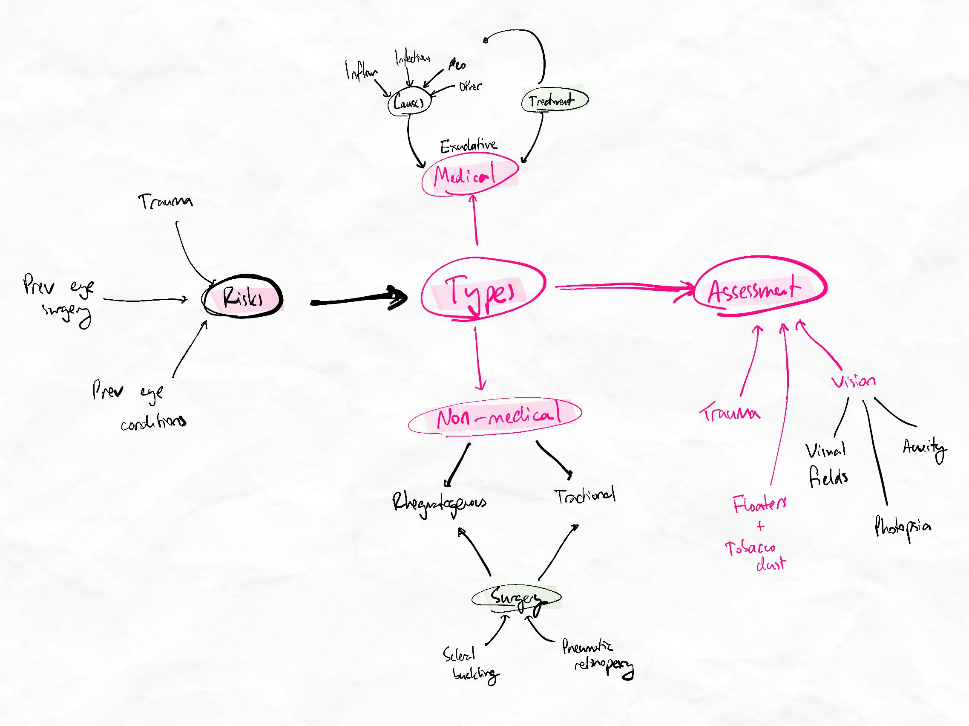Notice that the important relationships have been shown through better chunking, rather than just more lines and arrows.
You can see how much simpler and more intuitive it looks! Our chunks are starting to represent the judgments we have made on what is important and how they are related to each other.
As we continue to go deeper into each keyword and repeat this process for more detail, we may need to adjust our chunk structure again to fit more keywords and relationships.
Throughout the entire process, we use our chunking and non-linear note-taking to manage our cognitive load and keep it at optimum.

How we manage cognitive load
We strategically utilise our mental effort (increase cognitive load) to engage higher-order learning, and offload with chunking and non-linear note-taking to reduce cognitive load and prevent overload.
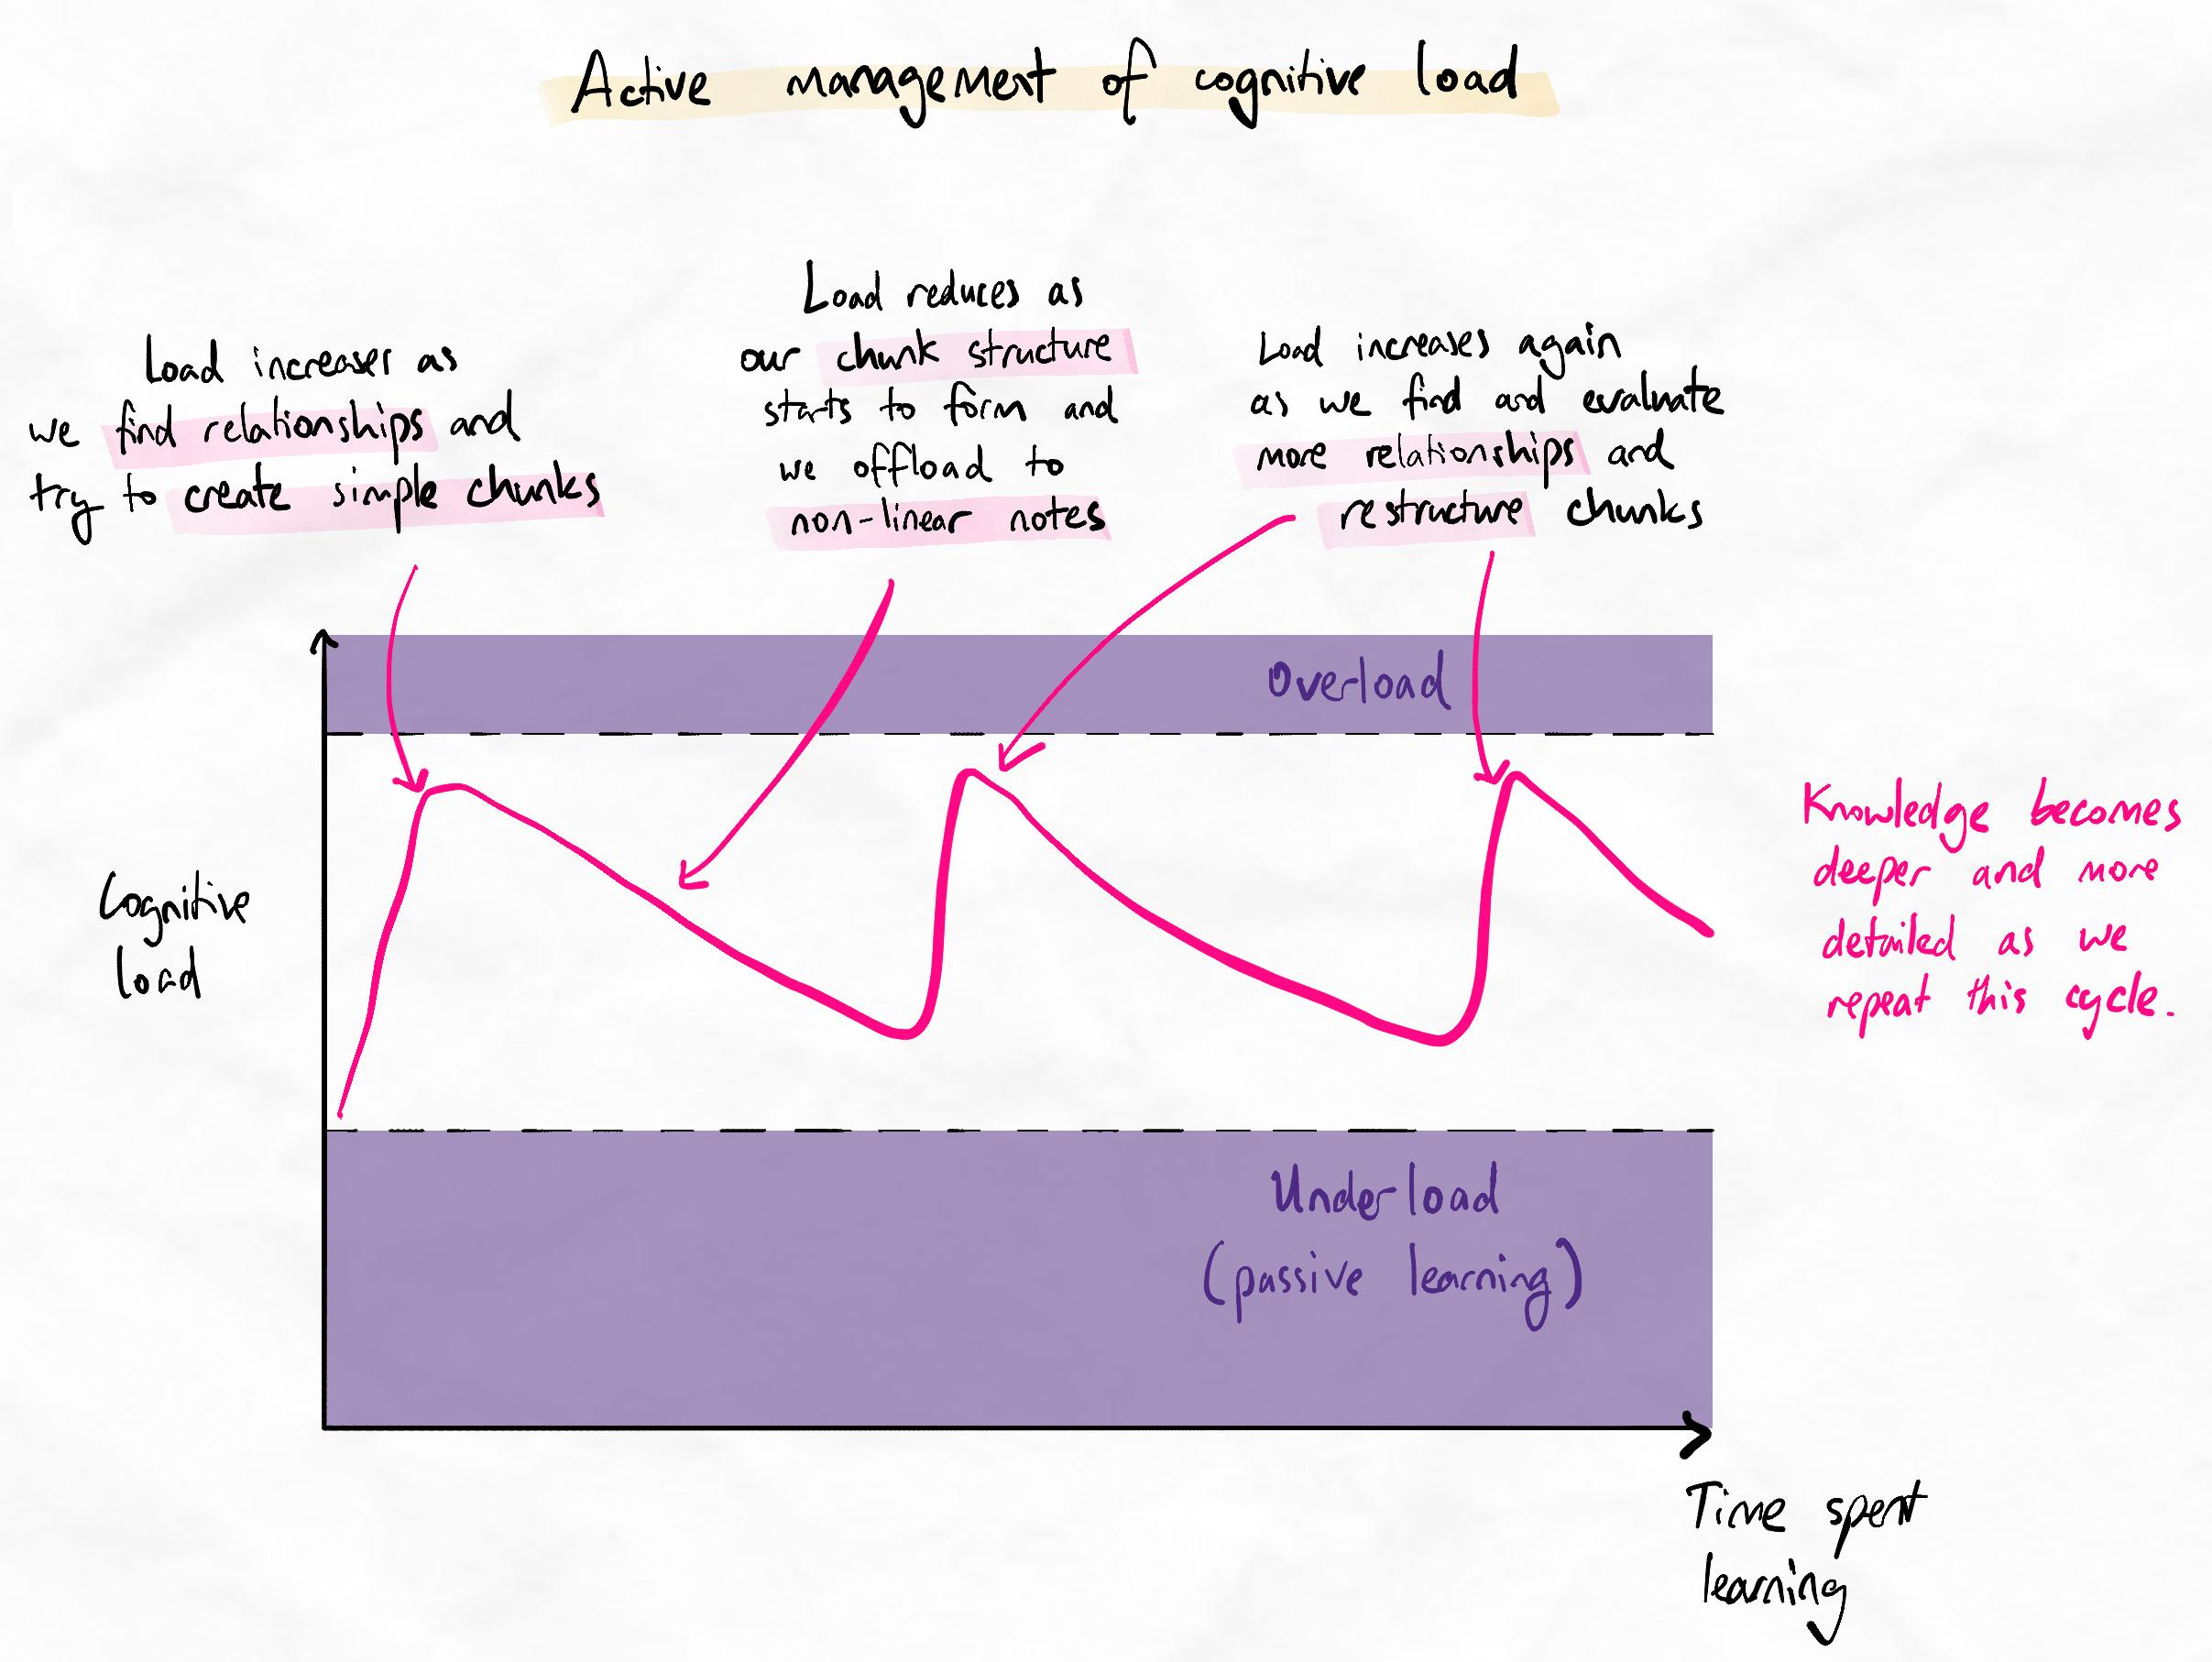Although we are preventing overload, the optimum range of cognitive load can still feel uncomfortable for those with primarily lower-order learning habits.
Inter-chunk relationships
Once we have importance-based chunks, we can then ask how these chunks (or sub-chunks) are related to and affect each other. This gives us inter-chunk relationships. When our inter-chunk relationships are clean, this creates a simple, clean backbone to our learning, making the learning process much faster.
The ability to do importance-based chunking and create clean inter-chunk relationships is one of the main differences between beginner and intermediate learners!
At this stage, we also want to completely remove “what” questions (i.e. fact or recall-based questions). These questions only lead to lower-order learning, whereas questions that force us to compare concepts against each other (e.g. why X is important, how it relates to Y) also produce higher-order learning.
One amazing thing about our brain is that when we do higher-order learning, it will automatically complete lower-order learning, too. This means that “why” and “how it relates” questions can completely replace “what” questions. It might seem impossible or counterintuitive, but just give it a go!
Importance gives our brain focus
Understanding why something is important gives us an idea of how the information is structured. In other words, we know how to think about the subject, which is incredibly important and a defining feature of an intermediate learner.
When our brain doesn’t know how to think about the subject, it’s trying to solve lots of problems at the same time:
- What does this mean?
- Why do I need to know it?
- How do I use this?
- Is this relevant?
- Do I need to memorise all the details?
- How do I solve problems with it?
- How does it fit in with everything else?
Since a lot is happening in your brain, you become less focused. This can cause you to spend more time and energy without learning much.
When information is not well-organised, retention is low.
The magic of structure
The convenient thing about learning how to think about something is that these general logical frameworks and patterns repeat.
A repeating pattern
As a young child, you might have thrown something on the floor. In doing so, you learned about a framework called “cause and effect”. You naturally interleaved this by throwing lots of things and hearing many noises.
Thus, the framework of evaluating how important something is through the lens of "cause and effect" is something that most people can understand easily as an adult.
Repeating frameworks and structures can be found in subject domains as well. You will discover many of them when asking why a concept is important. As you build experience, you will learn what questions and structures to ask to produce the most logical chunks.
Here are some common types of chunks you will find in different subjects. This list can help guide your thinking when considering why concepts from different subjects might be important.
Please note that this is not a comprehensive list. If you rely solely on this list to create importance-based chunks, you will encounter problems later. Instead, always start by asking yourself, “Why is it important?”.
Common patterns of importance
Biology
In biology, “importance” could mean chunking based on:
- Function
- Structure vs. function
- Scale (microscopic to macroscopic)
- A group of causes leading to a group of effects
Example: Instead of chunking organelles based on their location, try chunking them based on their function.
Chemistry
In chemistry, “importance” could mean chunking based on:
- Mechanisms of reaction
- Real-world applications
- Electronegativity
- Common reagents or products
Example: Instead of writing an unordered list, try chunking reactions based on the mechanisms that cause them.
Physics
In physics, “importance” could mean chunking based on:
- Real-world applications
- Conceptually important precursors to other concepts
Example: Instead of following the textbook, try chunking concepts and equations based on common applications.
Maths
In maths, “importance” could mean chunking based on:
- Real-world applications
- Conceptually important precursors to other concepts
Example: Instead of following the textbook, try chunking groups of equations that produce a certain effect on a graph.
English
In English, “importance” could mean chunking based on:
- The author/director/artist’s background, motivations or values
- The story’s significance
Example: Instead of writing an unordered list, try chunking themes and techniques based on which of the author’s values they derive from.
History
In history, “importance” could mean chunking based on:
- Major cultural, political, religious, philosophical or social movements at the time
- Cause and effect
- Predominant emotions or motivations of key players
Subjects like history may have the most diverse range of possible importance-based chunking structures. Since history tracks a massive range of human events and activities, there is also a diverse range of reasons why a historical event may be important.
Example: Instead of chunking events based on geographical location, try chunking them based on their motivating forces.
Law/Legal Studies
In law, “importance” could mean chunking based on:
- Underlying social principles of justice
- Pragmatic considerations and compensatory mechanisms
- Landmark cases that exposed gaps in the system
- Social, political or economic principles that must be protected
Example: Instead of listing cases and bills in isolation, try chunking them based on the underlying legal principles they relate to.
Languages
In languages, “importance” could mean chunking based on:
- Common usage
- Situational usage
- How they affect messaging or communication
Languages are the hardest to chunk by importance because languages are not inherently logical. In this case, importance would relate to how you intend to use the language.
Example: Instead of writing an unordered list, try chunking words and phrases based on their emotions or use cases.
Again, this list is just a reference to give you an idea of common structures you will encounter.
Recommended tasks
Add tasks to your focus list so you can practice the skills.
Dimensions
Ascent I
Practise importance-based chunking
Attempt to use importance-based chunking at least 3 times with a Kolb's after each session. Remember, success is to find your mistakes and knowledge gaps early!

Dimensions
Ascent I
Explore more interleaving methods
While your encoding abilities are growing in full stride, it's important to stay on top of our SIR. It's also important not to only stay in our SIR comfort zones. Some methods of retrieval may be new and unfamiliar, yet surprisingly helpful to add to your system.
Instructions:
Complete at least two more interleaved retrieval sessions, using at least one method from the interleaving table you have not attempted before.

- Barriers to aiming
Common objections
Using the BHS takes too much time.
This objection is understandable. The process of encoding the first time can take considerably longer when first learning the skill. Although this becomes faster and more efficient as your skill develops, the short-term consequence can still seem unacceptable.
However, when we start measuring the efficiency of our learning holistically, we find that although we can lose some time in the initial encoding, we more than make up for this even in the early stages of skill competence.
Read our article on how to accurately measure your learning efficiency here.

It's too hard! It takes too much effort and it's too tiring.
Effective learning always takes effort. Unfortunately, many learners have been conditioned to believe otherwise. In reality, avoiding difficulty and discomfort during learning is only viable for easy content at moderately low volumes.
With practice, you will learn to associate higher cognitive loads with effective learning. Instead of desirable difficulty only feeling difficult, you will start to feel that it is also desirable!
In other words, as your skill improves, the cognitive load does not reduce, but you become better at managing it and will no longer be bothered by it. Rather, many learners start to become bothered with passive learning because they realise how ineffective it is!

The questions I am thinking of aren't the same as how I am assessed.
When encoding information, we should always prioritise what our brain finds relevant. This is the shortest path to expertise. Once we have developed expertise, we can practise retrieving it in the way we need to for assessments.
This is much more efficient than limiting our encoding ability (and therefore forgetting more) by trying to match it artificially to assessments in the initial encoding phases.
An analogy for this is in constructing a network of roads in a city. Once the roads are constructed, you can use them in whatever way you want to get to wherever you need to!
You may also be concerned that your questions and learning sit outside the scope of an assessment. However, it is more efficient to go slightly outside the scope of a curriculum to improve your depth and retention of information instead of staying within the scope but suffering from reduced retention or depth.
You can also use your own judgment alongside learning objectives (if available) to prevent you from wandering too far from the topic’s scope.

Sublesson: Common chunking mistakes
Common chunking mistakes
Common chunking mistakes
Common mistakes
- No backbone
- Segmental mapping
- Framing bias
- Lower-order inquiry
- Importance checklist
- Insufficient chunking
- Aim examples
In the sublessons below, we demonstrate the usage of the Aim step across a variety of subjects. Even if your particular discipline is not included as an example, the methods of thinking are completely transferrable.
You can skip sub-lessons you are not interested in by marking them as complete. However, we recommend watching several different examples to get a clear understanding of the technique.
We recommend watching the following sublessons for all learners:
- Demonstration of core techniques
- Chunking for medicine
Both of these sublessons contain highly transferrable learning points for all subjects and disciplines.
Observe the process
Focus on the processes and approach to thinking about information rather than the actual example contents themselves.
Table of contents
Sublessons:
- Demonstration of core techniques 2
- Biology 1
- Biology 2
- Chemistry
- English and languages – introduction
- Languages – aim
- English – unfamiliar text
- English – text response
- Math
- Deep dive: anatomy
- Chunking for medicine

  - Demonstration of core techniques 2
Demonstration of core techniques 2
Before you watch
The following demonstration uses our interactive curriculum module as practice content. We strongly recommend that you attempt this yourself before reviewing the demonstration to make an accurate judgment of your true skill level.
You can access the interactive curriculum module from the Supplementary Learning page in your Toolkit.
This video has been intentionally edited to show the thinking time and thought processes involved in studying the topic.
Prechunking
Prechunking is when we create some chunks before engaging in inquiry.
In many cases, this is not advisable as it can bias the chunks we form. However, this is not problematic if we make sure our chunk structures are only hypotheses during the entire chunking process.
Problems arise when the prechunks do not serve as a springboard for thinking, but rather are assumed to be correct and learners are resistant or hesitant to modify it.
General advice about prechunking
- Prechunking is sometimes acceptable and saves time, but only if the chunks remain hypotheses and continue to be modified.
- If there is any difficulty with avoiding chunking in simply the same ways information is presented (i.e. engaging order control), avoid prechunking.
- If there are any issues with spiderwebbing or the Aim step feels ineffective, avoid prechunking.
In the demonstrations (both in the sublessons below as well as in Live Clinics) you will notice that sometimes prechunking is used and sometimes it is not.
What matters is that chunks are formed independently and challenged with good inquiry.

  - Biology 1
  - Biology 2
  - Chemistry
  - English and languages – introduction
English and languages have a few aspects we need to recognise before we can apply the Bear Hunter System. Once we understand the nature of these subjects, we can correctly apply the BHS to achieve top results much faster.
  - Languages – aim
Read more about comprehensible input hypothesis
Article about Stephen Krashen’s input hypothesis (of which comprehensible input is an important subset)
Wikipedia article on Comprehensible output (the other side of the language-learning coin, which we incorporate into later techniques)

  - English – unfamiliar text
  - English – text response
  - Math
Relevant Live Clinics
The following Live Clinics dive into applying these systems for math. If you struggle to apply the principles, we recommend watching the following Live Clinics:
Live Clinic 42: Mathematics - a case study
Live Clinic 41: Learning mathematics and troubleshooting
Live Clinic 25: The maths clinic
  - Deep dive: anatomy
Feel free to skip this lesson if you are not learning anatomy.
Overview
Many chunk structures can be used for learning anatomy. The goal is to reduce memorisation by creating chunk structures that offload the most difficult aspects. Avoid creating chunk structures that are so obvious they contribute nothing to your learning.
The following are potential chunk structures you can explore. In most cases, you will need a combination of these approaches, even within the same “region” of anatomy.
- Anatomical division (e.g. anterior vs. posterior)
- Functional division (e.g. flexion vs. contraction)
- Embryological rationale (can be highly effective if you keep it simple)
- Clinical application
A chunk such as “clinical application” can also be divided into multiple types of applications. Consider the differences between these clinical applications:
- Surgical approaches and techniques
- Forming differential diagnoses
- Urgency of management
- Mechanism of injury/disease
- Management complications
If you have never considered clinical applications this way, this is a high-yield area for you to look into. Not only will this help with your immediate retention, but it is also a method of thinking you are expected to be competent in during your clinical years.
Unfortunately, many medical schools do not prioritise this.
Gaining fluency
When chunking for anatomy, fluency is about identifying multiple possible chunk structures, then evaluating which approach feels most intuitive and reduces rote memorisation as much as possible.
Important
It is important to have these chunk structures in mind as soon as you begin studying. It would be inefficient to learn the information in isolation first and arrive at the structures later, since you are not giving the information relevance while you study it.
Framing bias can also make it difficult to consider alternative chunk structures. Even though information is usually retrieved in multiple ways during clinical practice, many students can only think of one way to chunk the information. This is a red flag indicating that the learner is heavily influenced by framing bias and how they “believe” the information needs to be structured.
Significant interleaving is essential in all learning, but especially anatomy. Make sure to test on alternative chunk structures and lower-order fact recall through spaced interleaved retrieval.
  - Chunking for medicine: Framing bias
Beyond medicine
Although this is a specific example of learning medicine, we recommend this sublesson for all learners. This sublesson discusses a common mistake called "framing bias", elaborated on below. Medical studies have been used to explain this concept because it is one of the strongest and most common ways that we see framing bias influence learning.
Framing bias
Framing bias is the cognitive bias that says that our conclusions and decisions are influenced by how the options are presented to us.
Framing bias in learning
In learning, framing bias commonly affects the chunks we form by making them similar to how information is chunked for us by teachers, resources, lectures, etc.
These chunks are often not the most cognitively optimal for our brain, which is why order control and independent chunking through the correct process of inquiry is crucial.
Find the way
Many learners conclude that there is no other way to chunk information because the way it is given to them seems logical and intuitive. However, there are often multiple ways to logically and intuitively chunk information while being cognitively more advantageous. Our job as learners is to find those ways, not accept that "there isn't any other way".
Below is an example of how a medical topic of retinal detachment can be chunked differently when we challenge framing bias.

Example
Iteration 1
This is probably the most common and obvious way to chunk this topic.
In the first iteration above, you can see that, at first glance, the topic seems organised. However, notice how everything funnels through the topic "Retinal detachment". The lack of lateral relationships also creates waterfalling. Many other diseases will have a structure that is almost identical to this. As a result, the information in this map will be forgettable and the learner will have to memorise all the terminal points of information.
Below, we now try to add lateral relationships to express the relationship between ideas.
Iteration 2
The text in pink represents a whole new chunk that was added which we discovered we missed by asking more lateral relationship questions.
In the next iteration above, we have introduced more lateral connectivity. However, it is disorganised. If we leave it here, we would have the problem of spiderwebbing.
By evaluating the connections, we can see that the chunk "Types" near the bottom has a high density of connections. If the concepts related to "Types" were chunked together, there would be no need for so many lines.
We must explore other chunk structures to try and resolve this. This process creates significant cognitive load and can take time.
Iteration 3
The same relationships have been expressed here as before.
In this final iteration, we have re-chunked the entire topic. The problems of waterfalling and spiderwebbing have been resolved using a different chunk structure. It also represents this topic in a more unique way, which makes it more memorable.
While it looks much cleaner and simpler, it (amazingly) retains the relationships identified in the second iteration. Moreover, the relationships are much easier to remember because they are reflected in the core organisational structure of the topic now.

- Distractions
Cognitive Switching Penalty
Modern research tells us that when we multitask, the quality of our focus is reduced, and we can only switch between two or three things rapidly. This is known as cognitive switching penalty.
This means that if we multitask while learning, the quality of our learning will decrease, and we will take longer to learn things because we are wasting time needing to refocus.
Key principle
Highly efficient people do not multitask. Instead, they concentrate on one task at a time to avoid the cognitive switching penalty. This is fundamental to developing deep focus.

References on cognitive switching penalty
Summary article here.
https://www.psychologytoday.com/us/blog/brain-wise/201209/the-true-cost-of-multi-tasking
- Maintaining focus
Increasing focus
Here are four easy techniques to increase your focus. Regardless of your experience level, we recommend ticking these off as a first step.
Techniques
- Intention Setting: Set specific, achievable goals you want to accomplish by the end of your study block. Make sure you physically write them down.
- Ritualisation: Create a set routine to prepare yourself to focus. This routine will help your brain to transition into high-focus mode automatically.
- Zone: Set up a study area that has zero distractions. Making sure you have no distractions while studying is extremely important for building focus.
- Cheat Sheet: If anything distracts you while studying, write it down on a cheat sheet and remove that distraction from your study zone.
References
The famous Marshmallow study showed that willpower is less important than the environment.
Functional magnetic resonance imaging (fMRI) studies showed some distraction pathways in our brain and the reward responses they trigger.
This study showed that the ability to resist temptation and distraction is independent of the ability to create and maintain focus.
Psyched Up: How the Science of Mental Preparation Can Help You Succeed is a book covering pre-performance ritualisation.
Pre-performance ritualisation helps with self-regulating pre-performance states and creating automaticity in high-skill task execution.

- Ascent I check
By the End of this Stage…
Technique(s) | Level of Competency
Bear Hunter System – Aim | You can consistently use concept lists to create high-quality questions that allow you to identify chunks, sub-chunks and the relationships between them.
Focus | You can consistently and easily optimise your focus in different environments.
Traffic Light System – Green light | You can answer Aim questions in processed notes that clearly represent chunks and relationships.
SIR | Your mastery of multiple interleaving methods is reaching unconscious competence. Your spaced retrieval is consistent.
Non-linear note-taking | Creating non-linear notes that reflect your higher-order learning is becoming substantially more comfortable.

Recommended tasks
Add tasks to your focus list so you can practice the skills.
Dimensions
Ascent I
Complete a challenge week and skill audit.
Use all of the methods you have learned so far for at least one week, with at least three Kolb's sessions. Once you have done this, complete a skill audit using the checklist items and meta-checklists available.
Complete this task once you have done your skill audit.

Table of contents
Quiz: Ascent I checkpoint quiz

- Ascent I checkpoint quiz
Spot the issues!
In the following quiz, we will show you some work submitted by real students. Each case has a common mistake for you to learn from. Sometimes, you will learn about certain mistakes for the first time from these checkpoint quizzes!
The impossible quiz
This quiz is designed for you to fail on your first attempt. This is because you will intentionally be tested on concepts that have never been explicitly taught to you.
Impossible quiz instructions
How to make the most out of these quizzes
- On your first attempt, try your best to get the questions correct by using logic and thinking about the principles you have learned. It is 'technically' possible to get each question right if you understand the principles very deeply!
- Review the learning notes at the end of the quiz and compare it with your own thought processes while you were answering them.
- Attempt the quiz again!

Question 1
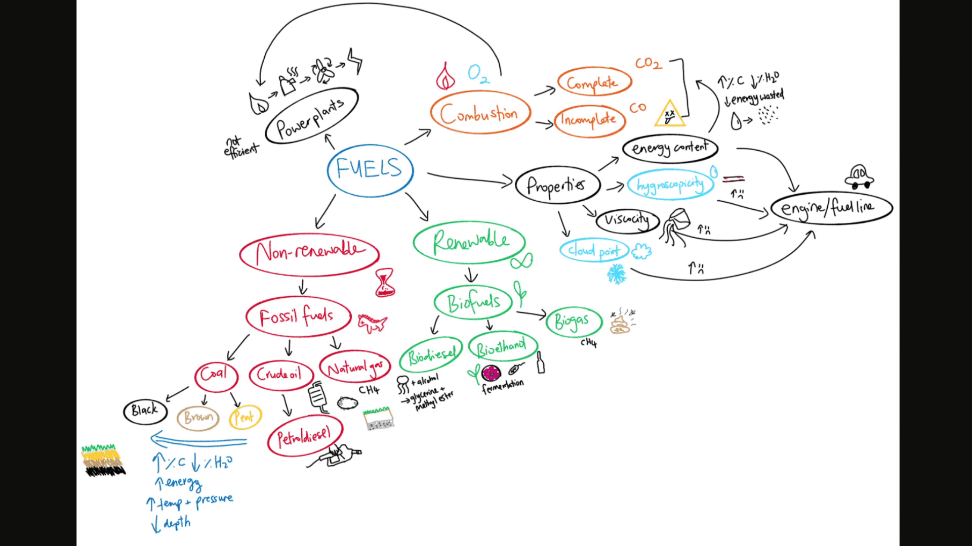
Regarding the work submitted by a student above, answer the questions below.
Which of these patterns are present? Select all that apply.
Lines over arrows
Lonely chunks
Equation chunked
Waterfall
Insufficient chunking
ANS: Waterfall

Question 2.1
Waterfalling is:
When there is one single central chunk with many other radiating relationships.
A method of hierarchical chunking that efficiently represents complex relationships.
A lack of sufficient chunking.
Lack of lateral connections between concepts.
Ans: Lack of lateral connections between concepts.
Question 2.2
Waterfalling occurs because:
The inquiry process is too detailed, causing weak order control and independent chunking.
The inquiry process is too superficial and does not sufficiently explore multiple relationships between ideas, leading to weak order control and independent chunking.
The inquiry process is performed on too many concepts at once, which makes it impossible to find enough relationships in time.
The inquiry process considers too many possibilities and relationships, leading to a chunk structure that is very hierarchical.
Ans: The inquiry process is too superficial and does not sufficiently explore multiple relationships between ideas, leading to weak order control and independent chunking.
Learning notes
Be Like Water
Waterfalling is an issue we commonly see in learners who are strongly influenced by framing bias. It indicates a pattern of mapping where the connections are “top-down” with very little connectivity between ideas that exist on the same “layer” of the map hierarchy. Waterfalling can be avoided by frequently thinking about how concepts relate to each other, even after they have been added into chunks. It’s also important to consider how chunks are related to other chunks.
It can be tempting to simply confirm that the only relationships are those we have already committed and thought about. However, high-level learners take the time to consider the relationships they have not yet thought about, as these could influence their chunk structure and, therefore, the quality of their memory and understanding.

Question 3
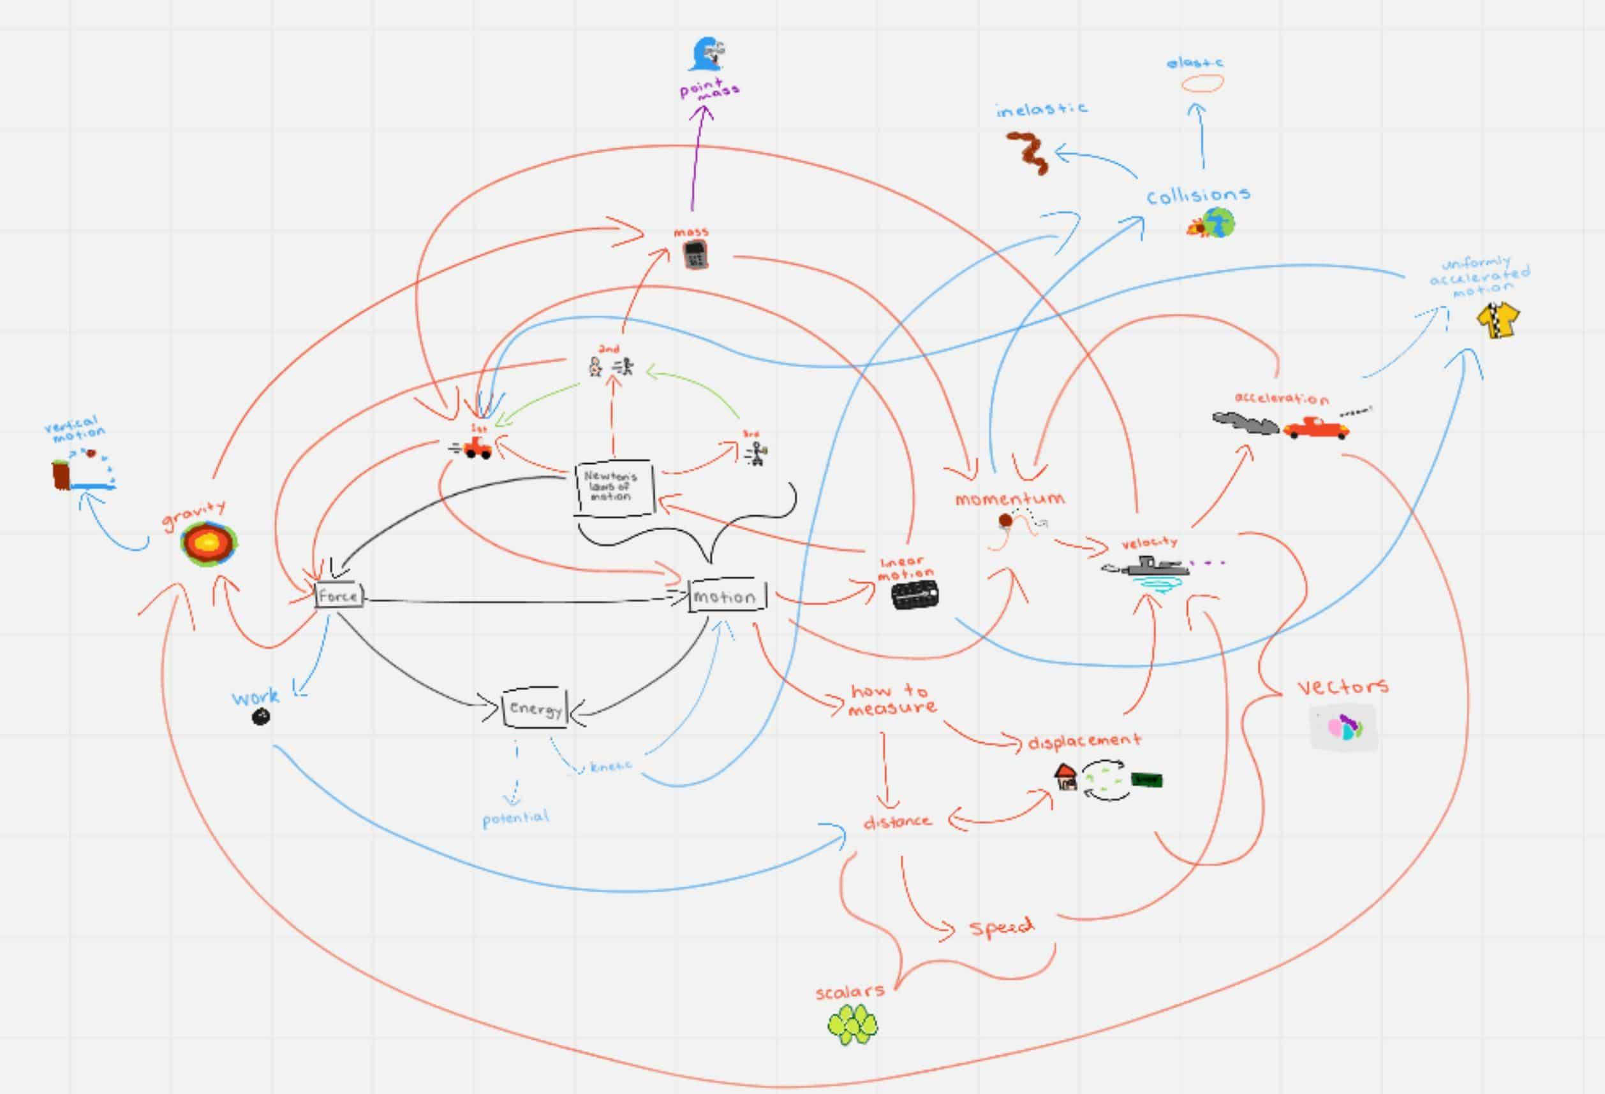
Regarding the work submitted by a student above, answer the questions below.
Which of these patterns are present? Select all that apply.
Spiderweb
Lonely chunks
Wheel and spokes
Lines over arrows
Waterfalling
Ans: Spiderweb

Question 4.1
Spiderwebbing is:
A messy map caused by having lots of arrows and lines connecting chaotically across the map.
Asking a question and writing the answer to it without exploring multiple possible answers.
Using too many visuals.
Not having a clear backbone of the main ideas because the main chunks have not been related with each other.
Ans: A messy map caused by having lots of arrows and lines connecting chaotically across the map
Question 4.2
Spiderwebbing can occur because:
Learners did not pre-study to identify the main ideas.
Learners did not anchor their visuals with a keyword.
Items on the map were placed into suboptimal chunks, without considering how the chunk contents are related to other concepts in the map.
Spiderwebbing can be a normal part of the mapping process before we refine the map to clean up the relationships and revise our chunk structures.
Ans: Items on the map were placed into suboptimal chunks, without considering how the chunk contents are related to other concepts in the map.
Spiderwebbing can be a normal part of the mapping process before we refine the map to clean up the relationships and revise our chunk structures.
Learning notes
Out Comes The Rain
We recommend you read our support article on spiderwebbing here. Importantly, spiderwebbing can be a normal occurrence during mapping as it is not realistic to consider every relationship while chunking. Often, we start with less optimal chunks, create spiderwebs, then identify how these can be refined and cleaned up in later iterations. An example of this is given in the chunking for medicine sublesson within the Aim examples lesson of Ascent 1.

Question 5
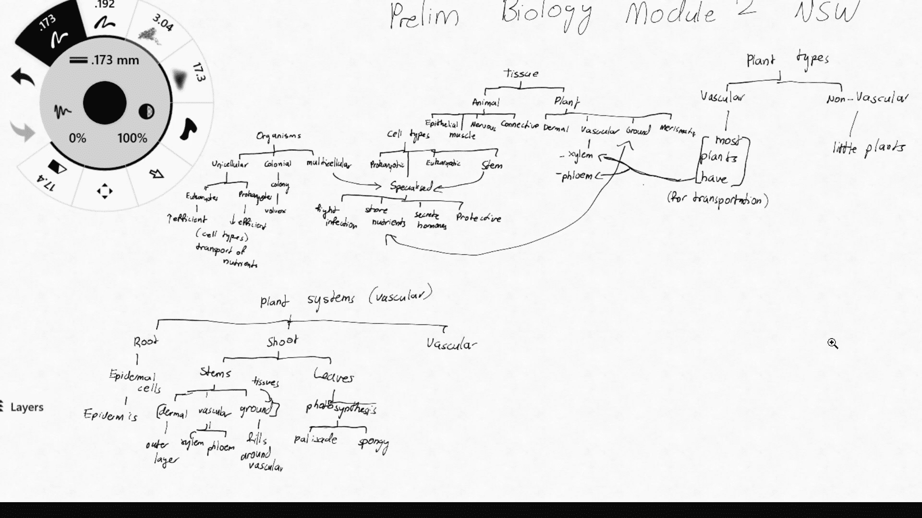
Regarding the work submitted by a student above, answer the questions below.
Which of these patterns are present? Select all that apply.
Waterfall
Spiderwebbing
Lonely chunks
Unshaped
No backbone
Hieroglyphics
Ans: Waterfall
Lonely chunks
No backbone

Question 6

Regarding the work submitted by a student above, answer the questions below.
Question 6.1
Lonely chunks is:
When there are very few chunks in a map.
When a chunk has very few connections branching off from it.
When there are multiple mini-maps that are not connected to each other.
When the learner feels lonely while they are chunking :(
Ans: When a chunk has very few connections branching off from it.
Question 6.2
Lonely chunks often occurs because (select the most correct option):
The learner only asked lower-order, “what” based questions that did not explore the multiple relationships between ideas.
The learner identified many relationships and tried to express all of them without considering how changing chunk structures could help to simplify the flow.
The learner explored only a single reason for importance after asking open-ended questions.
The learner did not independently form chunks based on shared similarities.
Ans: The learner did not independently form chunks based on shared similarities.
Learning notes
Antisocial Chunks
Lonely chunks refers to when chunks are created but contain no content. It is essentially a storage box with nothing inside it. This commonly occurs when topics are prechunked based on framing bias and not corrected by the inquiry process. If chunks are formed correctly based on identifying similarities between ideas and then looking for ways to group them, there should never be a chunk that is empty. This is because the chunk is defined by the potential contents in the first place.
Lonely chunks are acceptable when hypothesizing potential groups. However, this should be corrected while studying more as we realise this chunk is unnecessary. Keeping lonely chunks is detrimental to memory as it adds additional elements to our map and increases our cognitive load unnecessarily.

Question 7
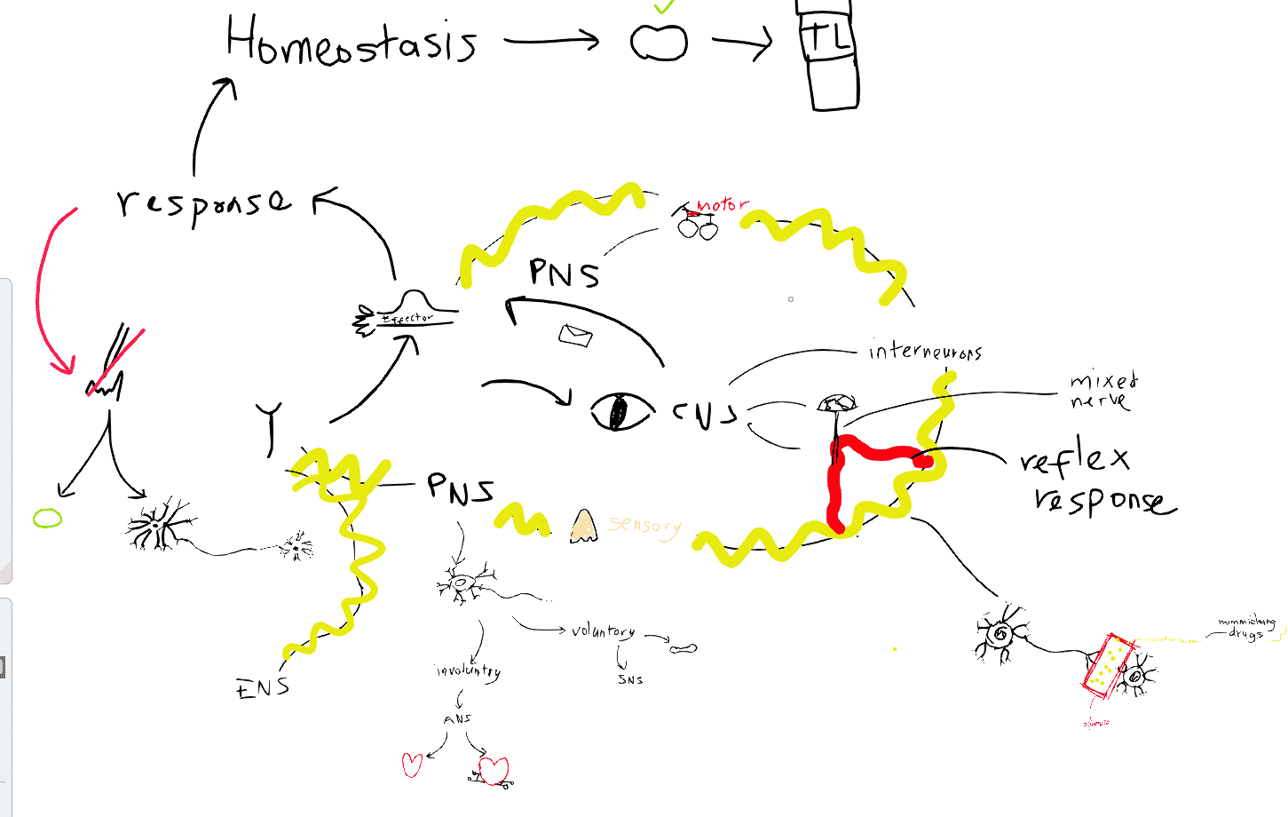
Regarding the work submitted by a student above, answer the questions below.
Which of these patterns are present? Select all that apply.
Lower-order inquiry
Wheels and spokes
Lonely chunks
No backbone
Too wordy
Waterfalling
Spiderwebbing
Ans: Lower-order inquiry
No backbone
Question 8

Regarding the work submitted by a student above, answer the questions below.
Question 8.1
Lower-order inquiry is:
Asking shallow questions that can lead to a lot of breadth, causing a lack of detail in the answers.
Asking “Why is this important?”
Asking questions for the sake of asking questions, almost as if one is ticking items off a checklist.
Asking questions about isolated facts, processes, or a single relationship between just two concepts.
Ans: Asking questions about isolated facts, processes, or a single relationship between just two concepts.
Question 8.2
Lower-order inquiry occurs because:
Learners are under time pressures that prevent them from engaging in proper higher-order thinking.
Learners have prior habits of lower-order, isolated thinking and have not developed the habit of thinking about multiple relationships and grouping based on similarities.
Some topics have a high level of unfamiliar terminology, which requires more lower-order questioning.
Lower-order inquiry must happen before higher-order inquiry and so is a natural part of the learning process.
Ans: Learners have prior habits of lower-order, isolated thinking and have not developed the habit of thinking about multiple relationships and grouping based on similarities.
Learning notes
Relationships Vs Chunking
Lower-order inquiry is when the questions asked promote only isolated thinking. This is detrimental to learning as this kind of thinking does not create strong memory or understanding. Lower-order inquiry can be avoided by following the question quality guidelines which keep questions broad, open and multi-relational.

Question 9
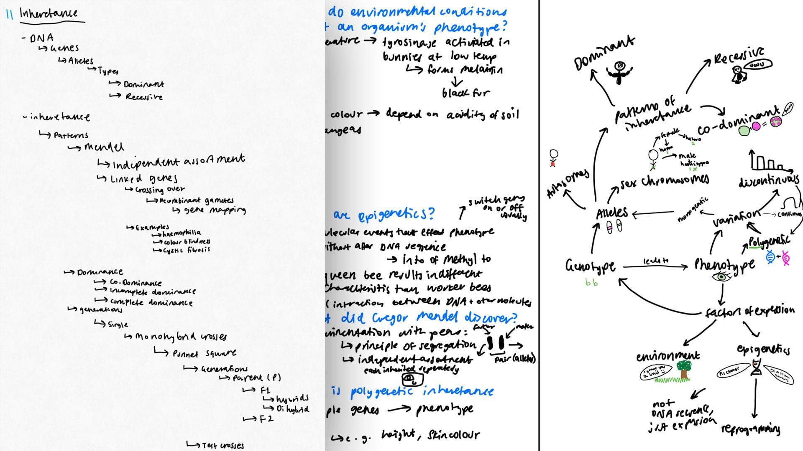
Regarding the work submitted by a student above, answer the questions below.
Which of these patterns are present? Select all that apply.
No backbone
Simple question and answer
Waterfalling
Spiderwebbing
Lonely chunks
Ans: No backbone
Simple question and answer

Question 10

Regarding the work submitted by a student above, answer the questions below.
Question 10.1
Simple question and answer is:
Asking questions that lead to only simple answers that have few relationships with other concepts.
When questions are answered very succinctly and efficiently to avoid unnecessary cognitive load.
Writing literal, often brief, answers to inquiry questions, closing off the potential for multi-relational, higher-order evaluation.
When questions are asked only based on prompts within existing resources, such as textbook practice questions.
Ans: Writing literal, often brief, answers to inquiry questions, closing off the potential for multi-relational, higher-order evaluation.
Question 10.2
Simple question and answer occurs because:
Learners have not understood that the value in asking questions is in the higher-order thinking that it invokes.
There are too many relationships within a topic to reasonably address during inquiry.
Some topics simply do not have many relationships between concepts.
Some questions are inherently simple and easy to answer.
Ans: Learners have not understood that the value in asking questions is in the higher-order thinking that it invokes.
Learning notes
Finding Flags- Ascent 1

